**EST Practical Activity Report**

**Submitted for**

**ENGINEERING DESIGN-II (UTA024)**

**Submitted by:**

102103815 Radhika Jasra

102103393 Rahul Gurwan

102103394 Pia Gupta

102103395 Priyanshi Kharbanda

102103813 Harshal Kumar Mehra

**Batch- BE Second Year (2CO14)**

**Submitted to-**

Dr. Nitika



**DEPARTMENT OF ELECTRONICS AND COMMUNICATION ENGINEERING, TIET, Patiala**

**January- May, 2023**

**INDEX**

|  |  |  |
| --- | --- | --- |
| S.No. | Description | Page No |
| 1 | First Page | 01 |
| 2 | Index | 02 |
| 3 | To draw a schematic diagram of receiver to receive specified pulse width IR signals from gantries using CAD tool (Eagle).  To design a printed circuit board layout of receiver circuit using CAD. | 03-06 |
| 4 | To design schematic diagram of IR sensors circuit which is used to track the path of the buggy.  To design Printed Circuit Board layout of receiver circuit using Eagle software. | 07-12 |
| 5 | To draw a schematic diagram of pulse width modulation (PWM) based transmitter for generating specified pulse width waveforms for gantries placed at different locations on the path using CAD tool (Eagle).  To design a printed circuit board layout of pulse width modulation (PWM) based transmitter using CAD tool (Eagle). | 13-18 |
| 6 | To solder and test pulse width modulation (PWM) based receiver circuit (to receive IR signals from gantries connected to transmitter circuit) on a printed circuit board (PCB). | 19-23 |
| 7 | To solder and test an IR sensor module circuit (which helps Buggy robot to move on a predefined path) on a printed circuit board (PCB). | 24-28 |
| 8 | To solder and test a pulse width modulation (PWM) based transmitter circuit (for gantries placed at different locations on the path to be followed by Buggy robot) on a printed circuit board (PCB). | 29-34 |

Experiment:1

**Objective:** To solder and test pulse width modulation (PWM) based receiver circuit (to receive IR signals from gantries connected to transmitter circuit) on a printed circuit board (PCB).

**Software Used:** Eagle Software (For Pre-Design)

**Component Used:**

|  |  |  |  |
| --- | --- | --- | --- |
| Sr. No | Name of Components | Value | Specifications |
| 1. | Resistor | 120kΩ,  100kΩ,  22kΩ,  1kΩ, | Carbon Resistor with 5% Tolerance |
| 2. | Capacitor | 100pF | Electrolytic Capacitor |
| 3 | BPW41N |  | Photodiode |
| 4. | LM311N |  | Operational Amplifier |
| 5. | 22-23-2031 |  | PCB Header |
| 6. | PCB (Printed Circuit Board) |  | General Purpose |
| 7. | Soldering Iron |  | NA |
| 8. | Soldering Wires |  | Melting Point: 200 Degree C  Diameter: 0-0.5 mm  Material: Tin Lead |
| 9. | DSO |  |  |

**Theory**: This circuit receives the signal and the voltage comparator analyses the signal to either carry forward the current or to cut the supply to the further circuit. The diode used is for faster operation of the circuit as this diode has fast switching speeds. We also the use of PCB headers and how it helps connect different components on to one circuit board.

1. **Resistor**: A resistor is a passive two-terminal electrical component that implements electrical resistance as a circuit element. In electronic circuits, resistors are used to reduce current flow, adjust signal levels, to divide voltages, bias active elements etc

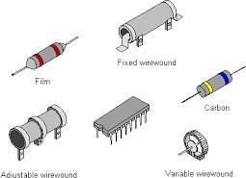

Fig. 1.1 Various types of resistors [1]

1. **Capacitor**: A capacitor is a device that stores electrical energy in an electric field. It is a passive electronic component with two terminals.

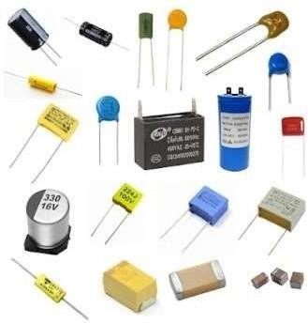

Fig. 1.2 Various types of capacitors [2]

1. **BP4WIN**: BPW41N is a PIN photodiode with high speed and high radiant sensitivity in a black, side-view plastic package with daylight blocking filter. The filter bandwidth is matched with 900nm to 950 nm IR emitters. It is used as a high-speed detector for infrared radiation and as an infrared remote control and free air data transmission system

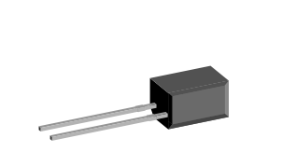

Fig. 1.3 BP4W1N [3]

1. **LM311N**: One of the simplest applications LM311 IC is a zero-crossing detector circuit which is shown as: As you know, like other comparators, if the voltage at the non-inverting input is greater than inverting terminal, the output comparator will be high. Otherwise, output will logic low.

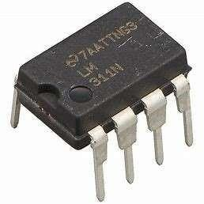

Fig. 1.4 Voltage Comparator LM311N [4]

1. **22-23-2031**: 22-23-2031 is a wire to board connector having 2.54 mm pitch and three contacts. It has nylon as its housing material.

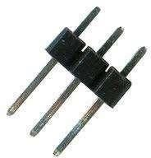

Fig. 1.5 PCB header [5]

1. **PCB Board**: A printed circuit board is a rigid structure that contains electrical circuitry made up of embedded metal surfaces called traces and larger areas of metal called planes. Components are soldered to the board onto metal pads, which are connected to the board circuitry. This allows components to be interconnected.

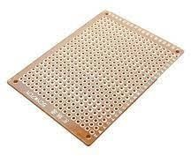

Fig. 1.6 PCB Board [6]

1. **Soldering Iron**: A soldering station is a multipurpose power soldering device designed for electronic components soldering. This type of equipment is mostly used in electronics and electrical engineering. Soldering station consists of one or more soldering tools connected to the main unit, which includes the controls (temperature adjustment), means of indication and may be equipped with an electric transformer. Soldering stations may include some accessories – holders and stands, soldering tip cleaners, etc. Soldering stations are widely used in electronics repair, workshops, electronic laboratories, in industry. Sometimes simple soldering stations are used for household applications and for hobbies.

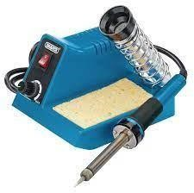

Fig. 1.7 Soldering Iron [7]

1. **Solder Wire**: Solder is a fusible metal alloy used to create a permanent bond between metal work pieces. Solder is melted in order to wet the parts of the joint, where it adheres to and connects the pieces after cooling. Metals or alloys suitable for use as solder should have a lower melting point that the pieces to be joined. The solder should also be resistant to oxidative and corrosive effects that would degrade the joint over time. Solder used in making electrical connections also needs to have favourable electrical characteristics. Alloys commonly used for electrical soldering are 60/40 Sn- Pb which melts at 188 °C (370 °F) and 67/37 Sn-Pb used principally in electrical and electronic work.

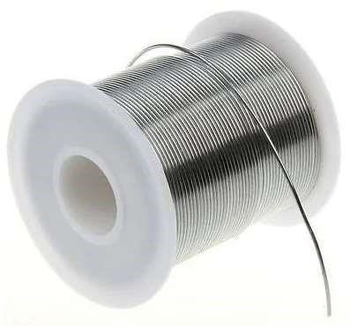

Fig. 1.8 Solder Wire [8]

1. **DSO (Digital Storage Oscilloscope):** A digital storage oscilloscope (DSO) is an oscilloscope which stores and analyses the input signal digitally rather than using analog techniques. It is now the most common type of oscilloscope in use because of the advanced trigger, storage, display and measurement features which it typically provides. The input analogue signal is sampled and then converted into a digital record of the amplitude of the signal at each sample time.

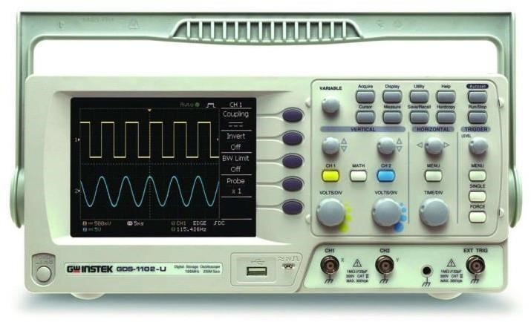

Fig. 1.9 DSO [9]

**Receiver circuit on PCB:**

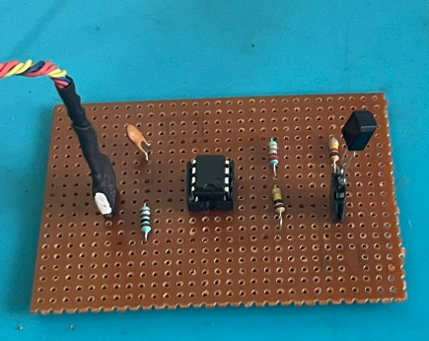

Fig. 1.10 Receiver circuit on PCB

**Output waveform (Digital Storage Oscilloscope):**

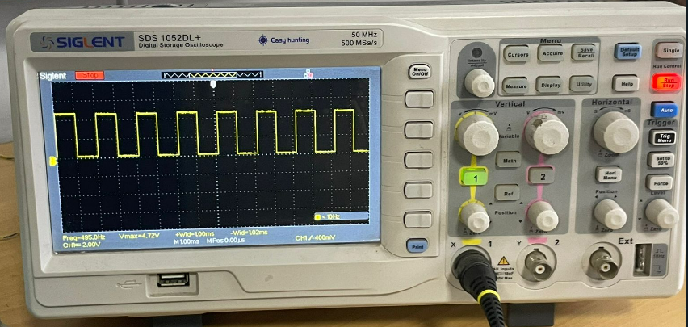

## Fig 1.11 Waveform (Pulse) detected by receiver circuit

**Discussion:**

In this experiment, we have learned how to design a circuit for receiver to receiver specified pulse width IR signals from gantries using a CAD tool. We also learned about various new components like 22-23-2031, BPW41N, and LM311N. The waveform obtained on the DSO was studied.

**Signature of Faculty member**

Experiment: 2

**Objective:** To solder and test an IR sensor module circuit (which helps Buggy robot to move on a predefined path) on a printed circuit board (PCB).

**Software Used**: Eagle Software (For Pre-Design)

**Component Used:**

|  |  |  |  |
| --- | --- | --- | --- |
| Sr. No | Name of Components | Value | Specifications |
| 1. | Resistor | 330kΩ, 10kΩ, | Carbon Resistor with 5% Tolerance |
| 2. | Potentiometer | 10 kΩ | 3 terminal resistors |
| 3 | BPX65 |  | Photodiode |
| 4. | SFH482 |  | Photodiode |
| 5. | LVM358MM |  | Operational Amplifier |
| 6. | MTA02-100 |  | AMP Connector |
| 7. | LED 3MM |  | Light source |
| 8. | PCB (Printed Circuit Board) |  | General Purpose |
| 9. | Soldering Iron |  |  |
| 10. | Soldering Wires |  | Melting Point: 200 Degree C  Diameter: 0-0.5 mm  Material: Tin Lead |
| 11. | DSO |  |  |

**Theory:** This circuit transmits and receives the signal from the IR transmitters and receivers, and sends signal if the path is clear or not.

1. **Resistor**: A resistor is a passive two-terminal electrical component that implements electrical resistance as a circuit element. In electronic circuits, resistors are used to reduce current flow, adjust signal levels, to divide voltages, bias active elements.



Fig. 2.1 Types of resistors

2. **LMV358MM**: An operational amplifier or op-amp is simply a linear Integrated Circuit (IC) having multiple-terminals. The op-amp can be considered to be a voltage amplifying device that is designed to be used with external feedback components such as resistors and capacitors between its output and input terminals. It is a high-gain electronic voltage amplifier with a differential input and usually a single- ended output. Op-amps are among the most widely used electronic devices today as they are used in a vast array of consumer, industrial and scientific devices.

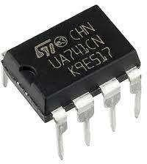

Fig. 2.2 LMV358MM

1. **Potentiometer**: The potentiometer is an instrument used for measuring the unknown voltage by comparing it with the known voltage. It can be used to determine the emf and internal resistance of the given cell and used to compare the emf of different cells.

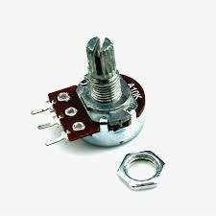

Fig. 2.3 Potentiometer

1. **LED 3MM**: A Light Emitting Diode (LED) is a special type of PN junction diode. The light emitting diode is specially doped and made of a special type of semiconductor. This diode can emit light when it is in the forward biased state.

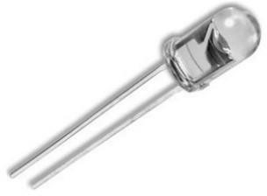

Fig. 2.4 LED

5. **SFH482**: It is used as a transmitter to make the schematic circuit complete in the IR receiver circuit

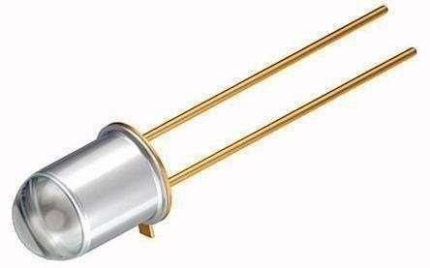

Fig. 2.5 SFH482

6. . **BPX65**: A device that converts light into an electrical current. The current is generated when photons are absorbed in the photodiode. They may contain optical fibres, and built-in lenses, and may have large or small surface areas.

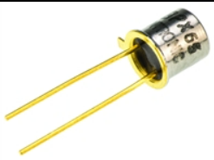

Fig. 2.6 BPX65

7. **MTA02-100**: The MTA connector system is a wire-to-board and wire-to-wire system based on insulation displacement contact (IDC)technology. Mass termination of wires supports low applied cost, as it drastically reduces the labour content of virtually any cable or harness assembly required.

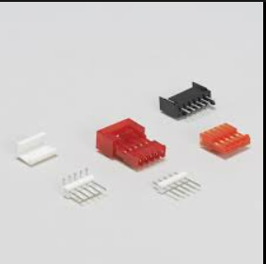

Fig.2.7 MTA02-100

8. **PCB Board**: A printed circuit board is a rigid structure that contains electrical circuitry made up of embedded metal surfaces called traces and larger areas of metal called planes. Components are soldered to the board onto metal pads, which are connected to the board circuitry. This allows components to be interconnected.



Fig. 2.8 PCB Board

9. **Soldering Iron**: A soldering station is a multipurpose power soldering device designed for electronic components soldering. This type of equipment is mostly used in electronics and electrical engineering. Soldering station consists of one or more soldering tools connected to the main unit, which includes the controls (temperature adjustment), means of indication and may be equipped with an electric transformer. Soldering stations may include some accessories – holders and stands, soldering tip cleaners, etc. Soldering stations are widely used in electronics repair, workshops, electronic laboratories, in industry. Sometimes simple soldering stations are used for household applications and for hobbies.



Fig. 2.9 Soldering Iron

10. **Solder Wire**: Solder is a fusible metal alloy used to create a permanent bond between metal work pieces. Solder is melted in order to wet the parts of the joint, where it adheres to and connects the pieces after cooling. Metals or alloys suitable for use as solder should have a lower melting point that the pieces to be joined. The solder should also be resistant to oxidative and corrosive effects that would degrade the joint over time. Solder used in making electrical connections also needs to have favourable electrical characteristics. Alloys commonly used for electrical soldering are 60/40 Sn-Pb which melts at 188 °C (370 °F) and 67/37 Sn-Pb used principally in electrical and electronic work.



Fig. 2.10 Solder Wire

11. **DSO (Digital Storage Oscilloscope)**: A digital storage oscilloscope (DSO) is an oscilloscope which stores and analyses the input signal digitally rather than using analog techniques. It is now the most common type of oscilloscope in use because of the advanced trigger, storage, display and measurement features which it typically provides. The input analogue signal is sampled and then converted into a digital record of the amplitude of the signal at each sample time.

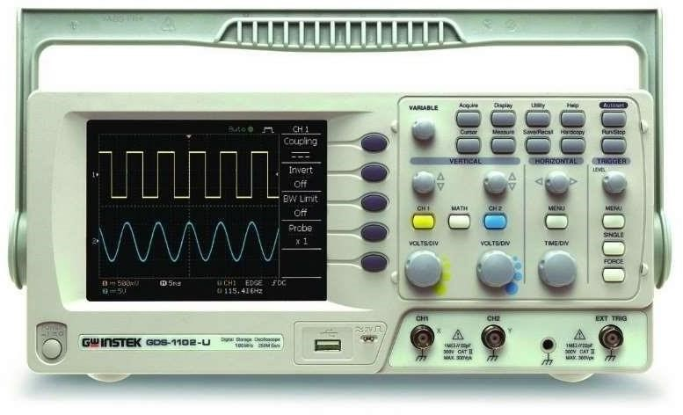

Fig. 2.11 DSO

**IR circuit on PCB:**

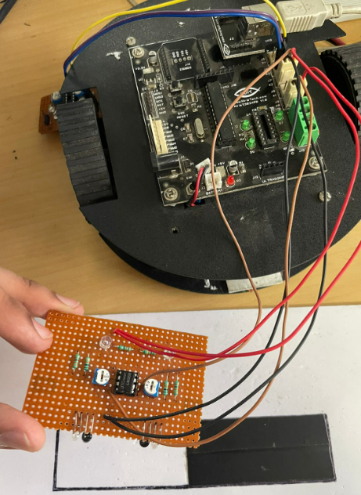

Fig 2.12 IR circuit on PCB

**Working of IR circuit :**

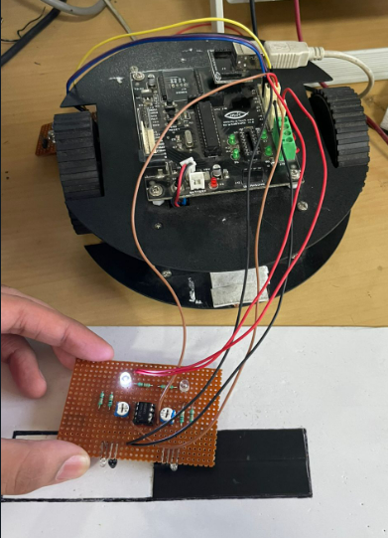

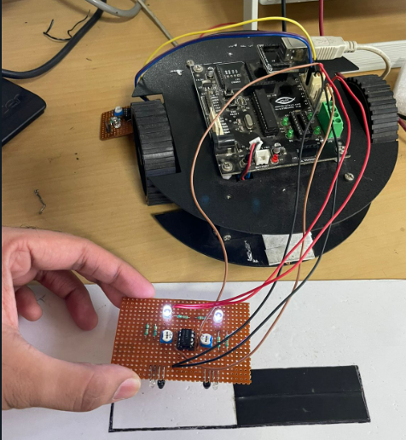

Fig 2.13 IR circuit working on dark and light surface

**Discussion:**

In this experiment, we learned how to design an IR sensor module. We came to know its importance in moving the buggy on a predefined path. Also, we learned about various components like LMV358MM, BPX65, SFH482, and MTA02-100. Practical working of the IR sensor was observed.

# Signature of Faculty member

Experiment: 3

**Objective:** To solder and test a pulse width modulation (PWM) based transmitter circuit (for gantries placed at different locations on the path to be followed by Buggy robot) on a printed circuit board (PCB).

**Software Used**: Eagle Software (For Pre-Design)

**Component Used:**

|  |  |  |  |
| --- | --- | --- | --- |
| Sr. No | Name of Components | Value | Specifications |
| 1. | Resistor | 330 Ω | Carbon Resistor with 5% Tolerance |
| 2. | Capacitor | 1 uF, 100 pF | Electrolytic Capacitor |
| 3 | DCJ0202 |  | DC power Jack |
| 4. | 7805TV |  | Voltage Regulator |
| 5. | LED 3MM |  | A two-lead semiconductor light source |
| 6. | 22-23-2031 |  | PCB header |
| 7. | Attiny85-20P |  | Microcontroller |
| 8. | PCB (Printed Circuit Board) |  | General Purpose |
| 9. | Soldering Iron |  |  |
| 10. | Soldering Wires |  | Melting Point: 200 Degree C  Diameter: 0-0.5 mm  Material: Tin Lead |
| 11. | DSO |  |  |

**Theory:**

This circuit receives the signal and the voltage comparator analyses the signal to either carry forward the current or to cut the supply to the further circuit. The diode used is for faster operation of the circuit as this diode has fast switching speeds. We also the use of PCB headers and how it helps connect different components on to one circuit board.

1. **Resistor**: A resistor is a passive two-terminal electrical component that implements electrical resistance as a circuit element. In electronic circuits, resistors are used to reduce current flow, adjust signal levels, to divide voltages, bias active elements etc



## Fig. 3.1 Various types of resistors [1]

2. **Capacitor**: A capacitor is a device that stores electrical energy in an electric field. It is a passive electronic component with two terminals.



## Fig. 3.2 Various types of capacitors [2]

3. **LED3MM**: An LED is a (light-emitting diode) is a semiconductor light source that emits light when current flows through it. 3mm LEDs are the smallest and are used in tight-fitting applications. They are popular due to their efficiency, range of colour, and long lifespan, LED lights are ideal for numerous applications, including night lighting, art lighting, and art outdoor lighting.

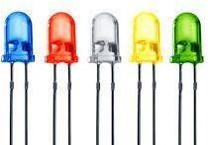

## Fig. 3.3 Various types of sub miniature standard LED

4. **7805TV**: This series of fixed-voltage integrated-circuit voltage regulators is designed for a wide range of applications. These applications include on-card regulation for the elimination of noise and distribution problems associated with single-point regulation. Each of these regulators can deliver up to 1.5A of output current.

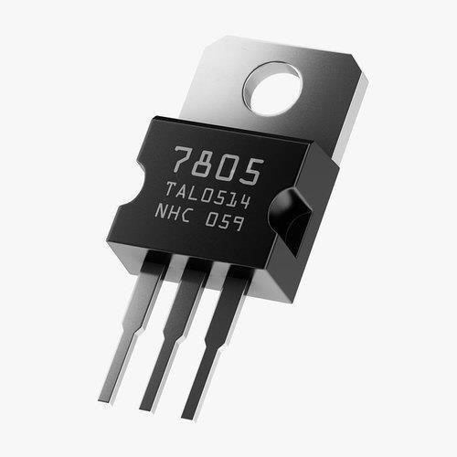

## Fig. 3.4 7805TV

5. **ATTINY45-20P**: It is a low-power CMOS 8-BIT microcontroller based on the AVR-enhanced RISC architecture. By executing powerful instructions in a single clock cycle, the ATTINY45-20P achieves throughputs approaching 1MIPS per MHz allowing the system designer to optimize power consumption versus processing speed.

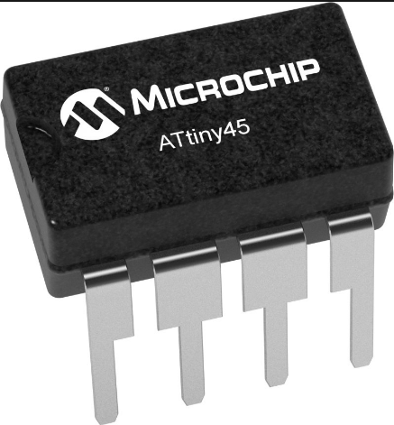

## Fig. 3.5 ATTINY45-20P

6. **DCJ0202**: It is a power connector or jack. This is a typical DC wall supply barrel style power jack. These have a 5.5 mm jack and a 2.1 mm centre pole diameter, and they are compatible with our DC wall supply.

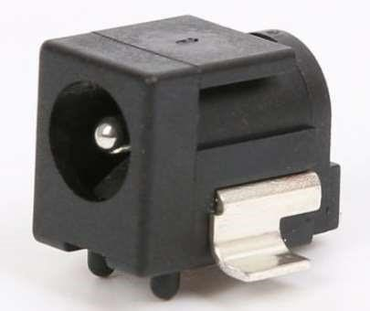

## Fig. 3.6 DCJ0202

7. **22-23-2031**: PCB (Printed circuit board) headers are a type of electrical connector that allows you to join connections to a PCB using a single block. Typically, PCB Connectors are used to transfer signals or power from one PCB to another, or to or from the PCB from another source in the equipment build.

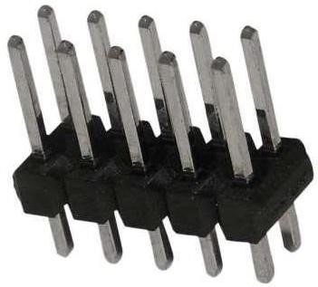

Fig. 3.7 22-23-2031

8. **PCB Board**: A printed circuit board is a rigid structure that contains electrical circuitry made up of embedded metal surfaces called traces and larger areas of metal called planes. Components are soldered to the board onto metal pads, which are connected to the board circuitry. This allows components to be interconnected.



## Fig. 3.8 PCB Board

9. **Soldering Iron**: A soldering station is a multipurpose power soldering device designed for electronic components soldering. This type of equipment is mostly used in electronics and electrical engineering. Soldering station consists of one or more soldering tools connected to the main unit, which includes the controls (temperature adjustment), means of indication and may be equipped with an electric transformer. Soldering stations may include some accessories – holders and stands, soldering tip cleaners, etc. Soldering stations are widely used in electronics repair, workshops, electronic laboratories, in industry. Sometimes simple soldering stations are used for household applications and for hobbies.



## Fig. 3.9 Soldering Iron

1. **Solder Wire**: Solder is a fusible metal alloy used to create a permanent bond between metal work pieces. Solder is melted in order to wet the parts of the joint, where it adheres to and connects the pieces after cooling. Metals or alloys suitable for use as solder should have a lower melting point that the pieces to be joined. The solder should also be resistant to oxidative and corrosive effects that would degrade the joint over time. Solder used in making electrical connections also needs to have favourable electrical characteristics. Alloys commonly used for electrical soldering are 60/40 Sn-Pb which melts at 188 °C (370 °F) and 67/37 Sn-Pb used principally in electrical and electronic work.



Fig. 3.10 Solder Wire

1. DSO (Digital Storage Oscilloscope): A digital storage oscilloscope (DSO) is an oscilloscope which stores and analyses the input signal digitally rather than using analog techniques. It is now the most common type of oscilloscope in use because of the advanced trigger, storage, display and measurement features which it typically provides. The input analogue signal is sampled and then converted into a digital record of the amplitude of the signal at each sample time.



Fig.3.11 DSO

**Transmitter circuit on PCB:**

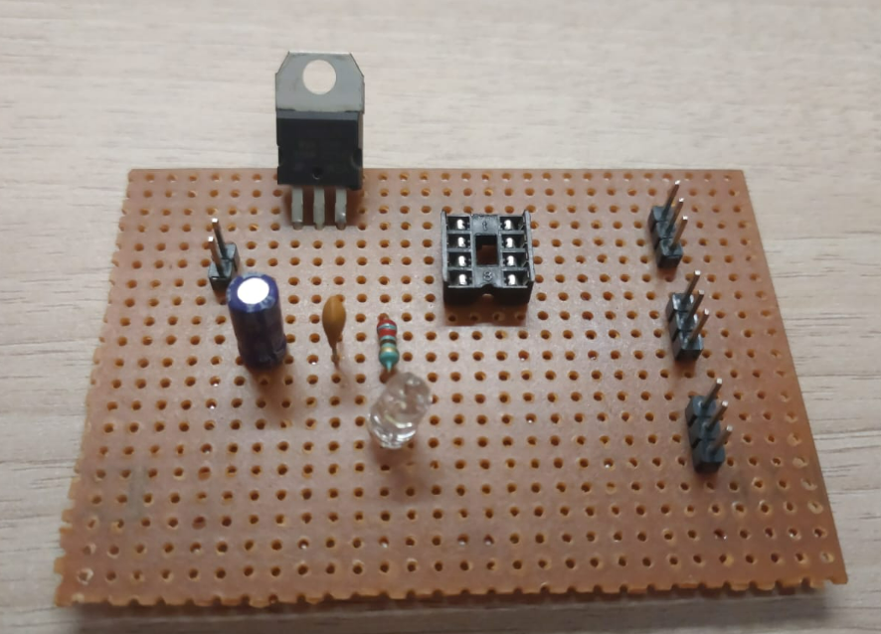

### Fig 3.12 Transmitter circuit on PCB

**Output waveform (Digital Storage Oscilloscope)**

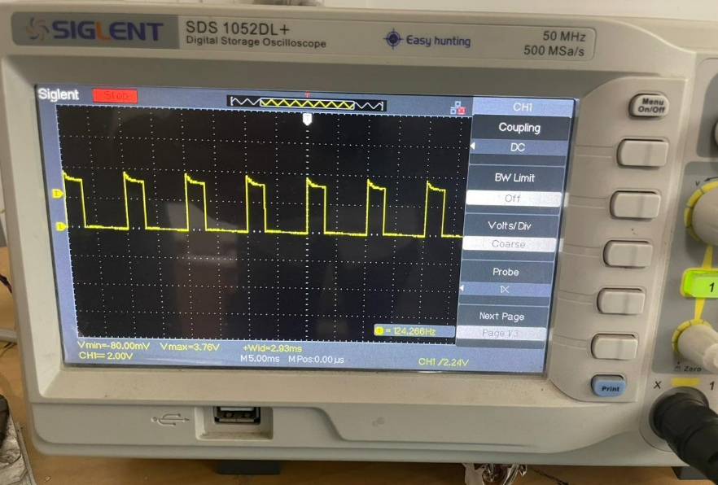

Fig 3.13(a) waveform obtained

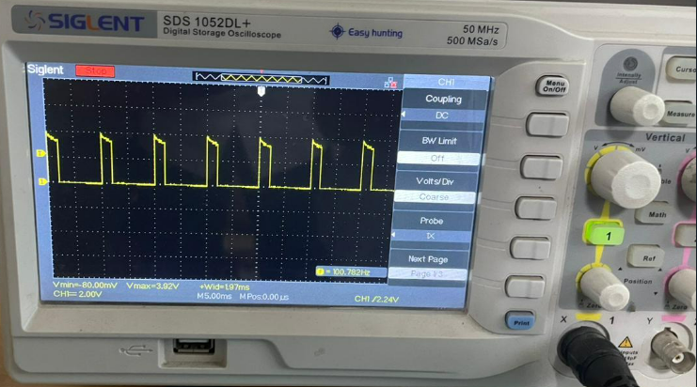

Fig 3.13(b) waveform obtained

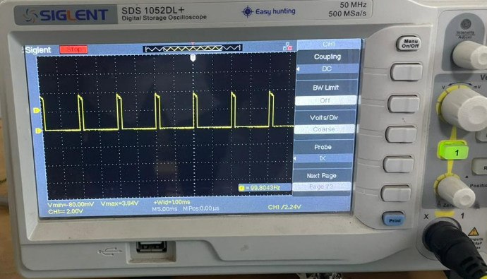

Fig 3.13(c) waveform obtained

**Discussion:**

In this experiment, we learned how to connect the components on PCB to make a transmitter circuit. We also learned about the working of various components like DCJ0202, 7805TV, ATTINY85-20P, and others. The three different waveforms obtained are noticed.

# Signature of Faculty member

**References:**

1. <https://en.wikipedia.org/wiki/File:Electronic-Axial-Lead-Resistors-Array.png>
2. <https://en.wikipedia.org/wiki/File:Capacitors_(7189597135).jpg>
3. <https://www.google.com/imgres?imgurl=https%3A%2F%2Fwww.microchip.com%2Fcontent%2Fdam%2Fmchp%2Fmrt-dam%2Fic-images%2Fpdip%2F8-lead-c4x%2FATtiny45-C4X-Regular.jpg&imgrefurl=https%3A%2F%2Fwww.microchip.com%2Fen-us%2Fproduct%2FATtiny45&tbnid=lT1zZTZbckmjSM&vet=12ahUKEwiz662Yibf7AhX9jtgFHSxJD_cQMygCegUIARC9Ag..i&docid=WqyoTXFXPI6-OM&w=800&h=857&q=microcontroller%20attiny45&hl=en&ved=2ahUKEwiz662Yibf7AhX9jtgFHSxJD_cQMygCegUIARC9Ag>
4. <https://www.google.com/imgres?imgurl=https%3A%2F%2F5.imimg.com%2Fdata5%2FMX%2FUS%2FMY-31943670%2Flm7805-voltage-regulator-ic-dip-500x500.jpg&imgrefurl=https%3A%2F%2Fwww.indiamart.com%2Fproddetail%2Flm7805-voltage-regulator-ic-dip-19996198155.html&tbnid=Wure1sQCjNbN6M&vet=12ahUKEwjQ18Teibf7AhVJj9gFHcrkCq0QMygDegUIARCHAg..i&docid=3niL9M0CyjhTtM&w=500&h=495&q=Voltage%20Regulator%20(IC%2078L05&ved=2ahUKEwjQ18Teibf7AhVJj9gFHcrkCq0QMygDegUIARCHAg>
5. <https://www.google.com/imgres?imgurl=https%3A%2F%2Fcdn-learn.adafruit.com%2Fguides%2Fcropped_images%2F000%2F000%2F206%2Fmedium640%2FLEDrainbow.jpg%3F1534968137&imgrefurl=https%3A%2F%2Flearn.adafruit.com%2Fall-about-leds%2Fwhat-is-an-led&tbnid=ecdFLh_z16_1tM&vet=12ahUKEwih25eRirf7AhV_i9gFHSQ6BmYQMygGegUIARDxAQ..i&docid=nIXvE2askHGESM&w=640&h=480&q=led&ved=2ahUKEwih25eRirf7AhV_i9gFHSQ6BmYQMygGegUIARDxAQ>
6. <https://en.wikipedia.org/wiki/File:6_Pin_Header.jpg>
7. <https://www.google.com/imgres?imgurl=http%3A%2F%2Fsc04.alicdn.com%2Fkf%2FHTB12hpvXPDuK1RjSszd760GLpXar.png&imgrefurl=https%3A%2F%2Fwww.alibaba.com%2Fproduct-detail%2F2-1mm-waterproof-dcj0202-dcj0202-dc_60816335066.html&tbnid=SurvUZtJIX0ejM&vet=12ahUKEwiV_qS3irf7AhWt_jgGHVc7Dp0QMygCegUIARDIAQ..i&docid=erIuONiekSEcNM&w=702&h=702&q=.%20DC%20Jack%20(DCJ0202&ved=2ahUKEwiV_qS3irf7AhWt_jgGHVc7Dp0QMygCegUIARDIAQ>